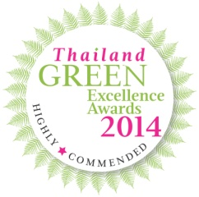
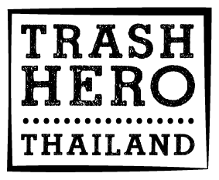
Trash Hero Thailand Wins Thailand Green Excellence Award

November 11, 2014
Koh Lipe, Thailand — We are thrilled to announce that the Thailand Green Excellence Awards has recognized Trash Hero Thailand with the status of “Highly Commended” in the category Nature, Maritime & Heritage. Her Royal Highness Princess of Thailand Ubol Ratanarachakanya Siriwatanaphanwadi presented the awards at a prestigious ceremony hosted at the World Travel Market on November 3rd in London, United Kingdom. These awards are presented by the Tourism Authority of Thailand (TAT) UK, and are intended to highlight and further promote Thailand’s dedication to the conservation of its precious natural and cultural resources, and support sustainable tourism development.

"We are very honored to be given this award. It motivates us to continue our work of preserving Thailand’s amazing natural beauty" said Roman Peter of Trash Hero Thailand. "We accept this award on behalf of the over 1,100 People who helped us clean the beaches, and also on behalf of the many people and businesses on Koh Lipe who have supported us since we began our work in December 2013."

Trash Hero Thailand organizes beach cleanups every Monday, taking locals, kids and tourists to various beaches throughout the Koh Tarutao National Marine Park. “We have been amazed by the generosity of both Thai and foreign tourists who have joined our Monday Cleanups project,” said Roman Peter, who co-founded the group with his local friend Nirut “Yaman” Chochuang. Koh Lipe is an increasingly popular tourist destination, and is the only island in the National Marine Park, which allows tourism development.

Following on the success of its Monday Cleanup project, Trash Hero Thailand recently announced plans for two new projects on Koh Lipe and Koh Rawi islands, both part of the National Marine Park.

Find out more about the Thailand Green Excellence Awards and a complete list of winners at
http://uk.blog.tourismthailand.co.uk/2014/11/03/2014-thailand-green-excellence-award-winners-announced/

Contact English: Roman Peter, +66 (0) 87 396-2465, info@trashhero.org
Contact Thai: Yaman (Nirut Chochuang), +66 (0) 89 467-2132, info@trashhero.org

Additional information on the organization: www.trashhero.org

